
FULL / EMPTY VBS Quick Task Guide

Log in LINK: Propel


Please expand the Left hand panel for options -  and select 
This will take you to your Container Appointments screen:
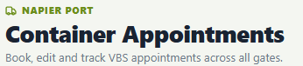

Select 
GATES: 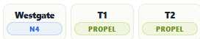
WESTGATE = Napier Port, 88 Breakwater Rd, Napier / FCL’s or Rail only.
T1 = Thames 1 Depot, 90 Thames St, Napier / Empty PICK UP only.
T2 = Thames 2 Depot, 75 Thames St, Napier / Empty DROP OFF only.

To book a slot: Select the Gate and Zone required by clicking on the remaining slots buttons as per the red dots below.
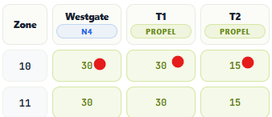

APPOINTMENT SCREENS
This will pop up an appointment screen to complete your transaction details. Rego / Container / Group # / Release # depending on which Gate you are using.
If you have multiple appointments for one Truck Visit IN THE SAME LOCATION/GATE for the SAME MOVEMENT TYPE (eg Drop Off) you can select + Add Trailer then + Add container for the next transaction.
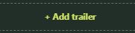
You can move your containers around on the trailers to confirm the correct positions required.
WESTGATE = Napier Port, 88 Breakwater Rd, Napier / FCL’s or Rail only.
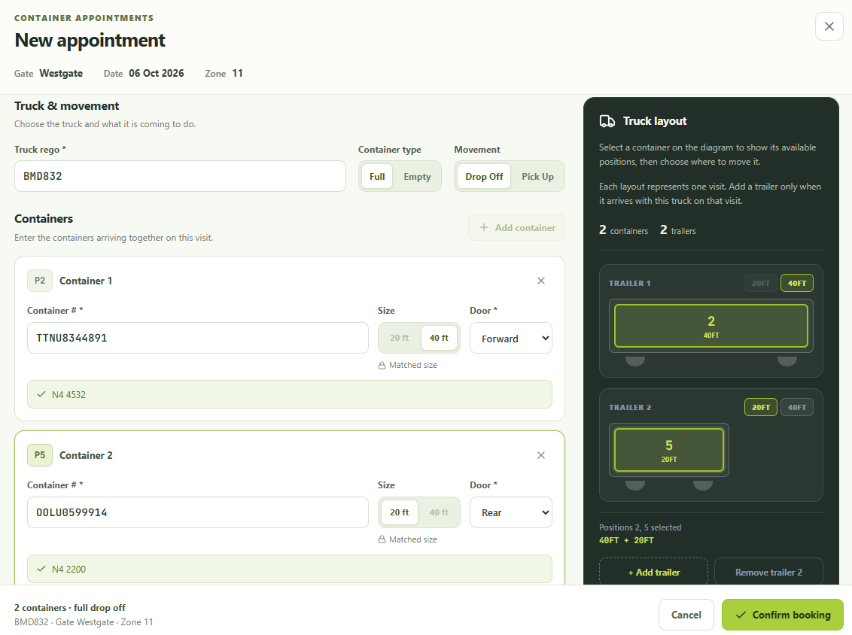

Door Directions are compulsory for both Drop Off and Pick Up now 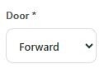 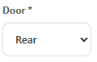

T1 = Thames 1 Depot, 90 Thames St, Napier / Empty PICK UP only.
Input Truck Rego, Release # & Door Direction and Confirm Booking.
Green means we have stock at time of appointment
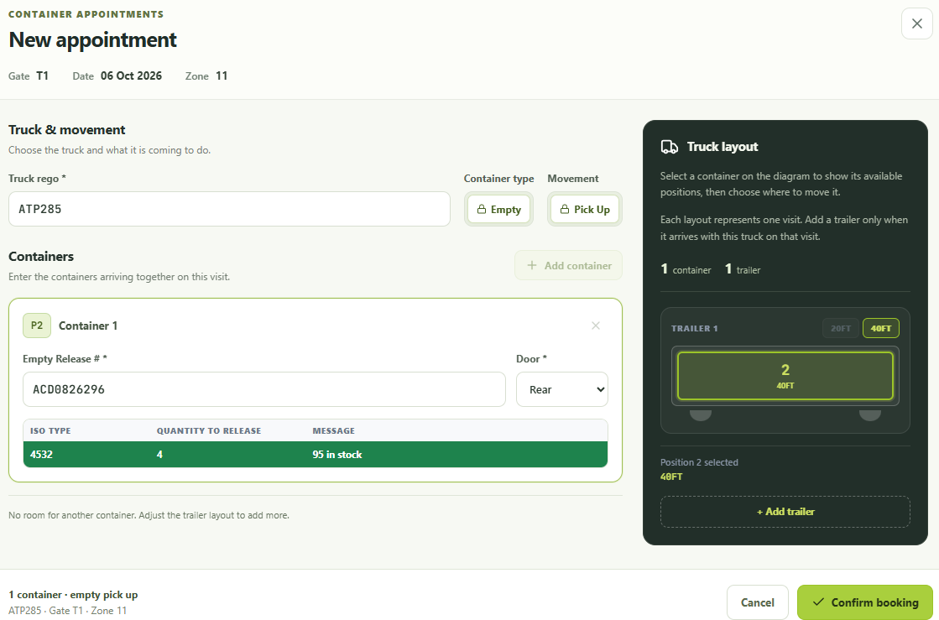
Orange means email the Depot ( depot@napierport.co.nz ) to check on Stock availability as they may just need to change a grade to be able to supply your request.
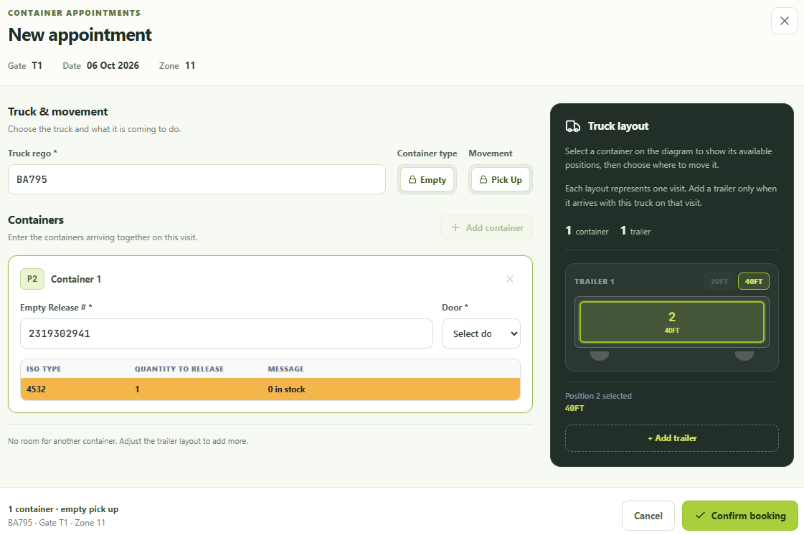

Release is not currently active means we have not had the EDI from the Shipping Line – email the Depot to check (depot@napierport.co.nz ).
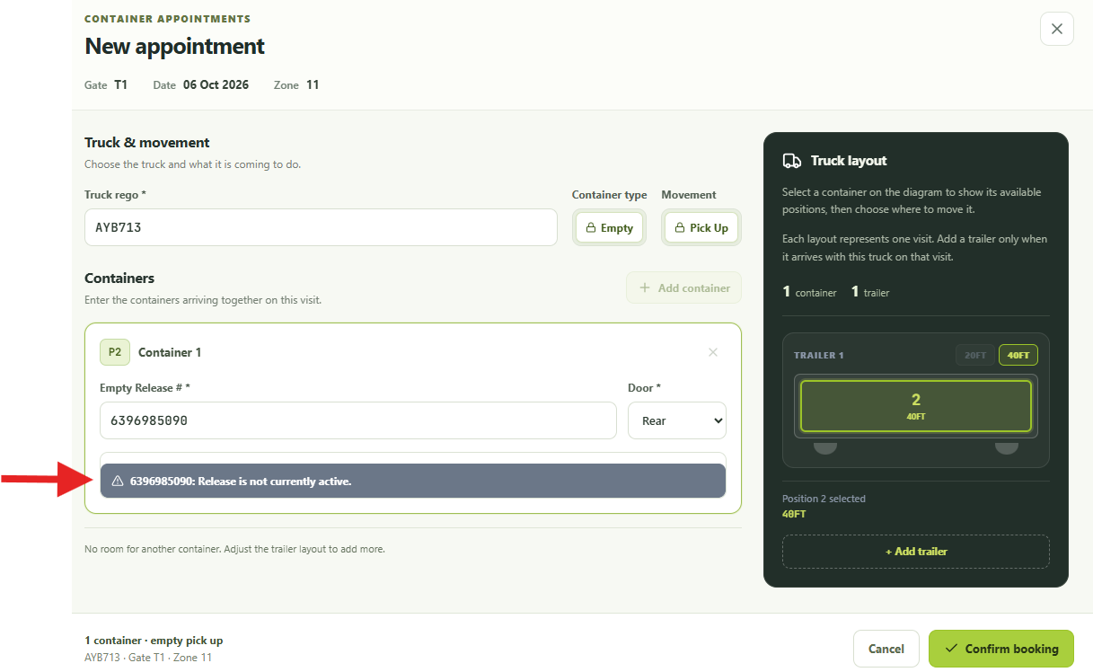

T1 – Pick Ups – Current Appointments LIST
Once the Forklift has Completed the transaction the container number uplifted will appear on your Current Appointments List in grey (Refresh ).
It will stay there for 10 Minutes then will move to your Completed / cancelled / expired List.

T2 – EMPTY Drop Off only – input Rego & Empty container number and Confirm Booking.
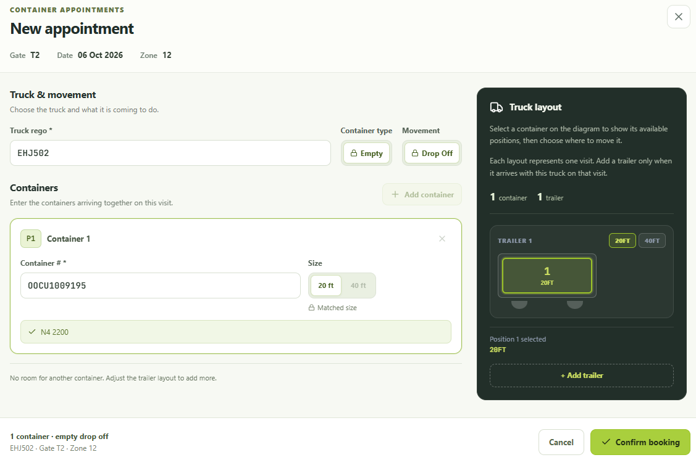

APPOINTMENT LIST: You can use your Filters button as follows to refine the visibility to your List.
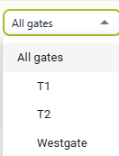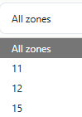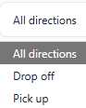


TO CANCEL AN APPOINTMENT
Press the cancel button PRIOR to the start of the required zone at any time if the booking is no longer required.

If the hour has started you must contact westgate@napierport.co.nz to cancel your appointment. If you do not email to cancel you will be charged a No Show fee.

ISSUES
Depot – email depot@napierport.co.nz If urgent phone 068334472
Gatehouse – email westgate@napierport.co.nz If urgent phone 068334357

