


Export Pre-Advice Quick Task Guide

Log in LINK: Propel
Please expand the Left hand panel for options - 
Select the Export Pre-Advice icon – left hand panel

Export Pre-Advice Page
Select + New Export Pre-Advice to start.
To complete the Export Preadvice
As you complete each section (page) press NEXT to carry on to Submit/Completion on page 4.
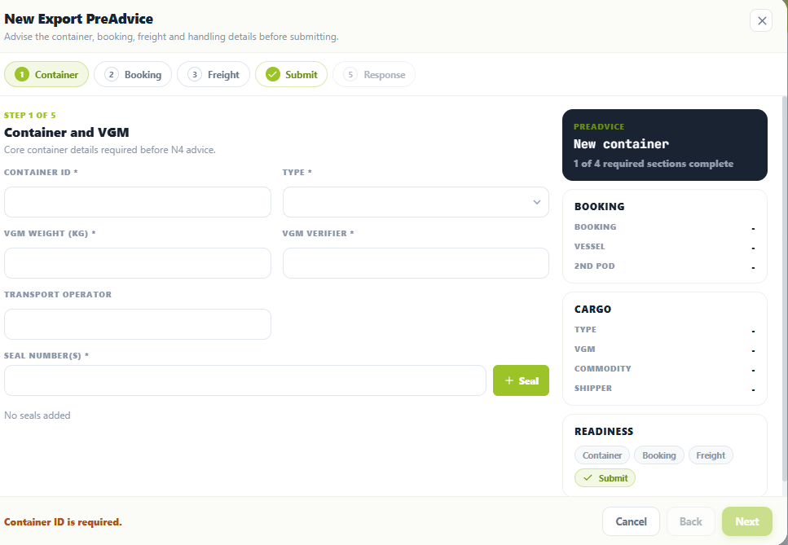

Pack Point Codes
Your Pack Point codes are advised on email when you Register for Propel Export Pre-advice.

MULTIPLE Pre advices at one time
If you have multiple pre-advices to complete against THE SAME EXPORT BOOKING please select the Same booking box below and Advise Another Unit and the system will hold and display some of the previous information for you.
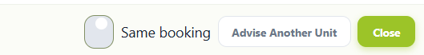
Once each pre-advice is SUBMITTED please ensure you REFRESH the system so each submission appears on your Pre-advice List before you start your next pre-advice.
EMAIL CONFIRMATION
You will receive your Export Pre-advice EMAIL confirmation when you press SUBMIT.
EDIT Function
If you find an error or need to update any information in your Pre-advice please use the EDIT Function in your Pre-advised container list.
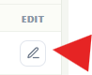

If you need to DELETE a pre-advice please contact the Western Gate – westg@napierport.co.nz who will delete this for you.
LIST
All pre-advices will sit in a list on your page in Propel and will show the various Status’s as the container progresses:
Pending – (pending acceptance into Port system).
Inbound (Pre-advice successful).
EC/In (at Gate).
Yard (In Terminal).
EC/Out (programmed to vessel).
Loaded (On vessel).
It will disappear from your list once the vessel has Departed.

EG:
