


Log in LINK: Propel

Import Advice Quick Task Guide

Please expand the Left hand panel for options - 

Select the Import Advice icon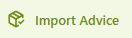
Create - Group Stack/Half Day Pickup:
Check if vessel is locked off at the top of the page. Note: you cannot assign containers if the vessel is locked off for planning.
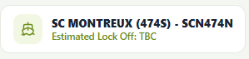
- Copy and paste Import container numbers into the ‘ENTER CONTAINER NUMBERS SEPARATED BY SPACES, COMMAS, OR NEW LINES…. And press Advise
- Select the half day or Block Group option as required and Apply.
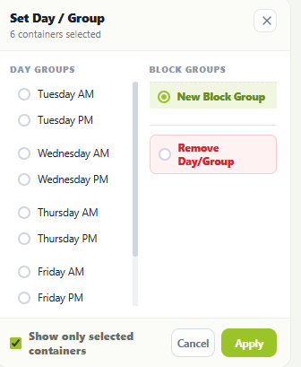

Change/Remove
To change a pick-up day or group stack for a container that is already Import Advised, re-enter the container numbers into “Advised Containers”, and change details as required.
To remove a pick-up day or group stack, re-enter container number into “Advised Containers” and select “Remove Day/Group”.
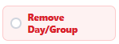

Tips and Tricks
- Select the Appointments icon - left hand panel
- There is a function to view and edit your currently Import advised (but not yet VBS Booked) containers.

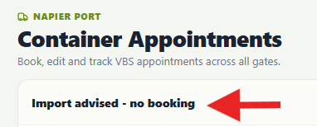

Select the box to immediately VBS your container.

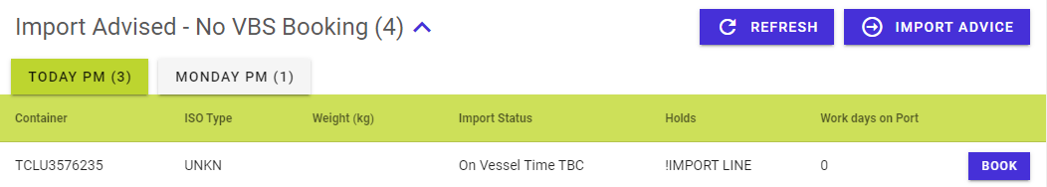
- You get a green tick in a Truck iconto show you which containers on your Import List
already have their VBS booking.

